Student Name: __________________

**Project: H-tree fractal**

Problem Description:

An H-tree is a fractal defined as follows:

1. Begin with a letter H. The three lines of the H are of the same length, as shown in Figure a.

2. The letter H (in its sans-serif form, H) has four endpoints. Draw an H centered at each of the four endpoints to an H-tree of order 1, as shown in Figure b. These H’s are half the size of the H that contains the four endpoints.

3. Repeat step 2 to create a H-tree of order 2, 3, ..., and so on, as shown in Figure c-d.

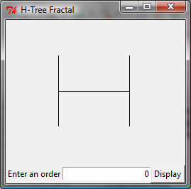 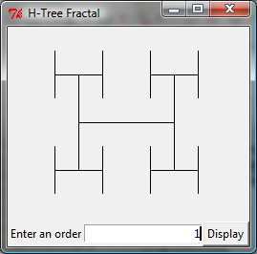 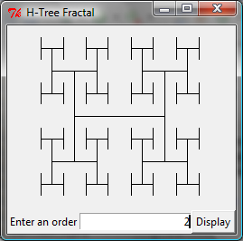 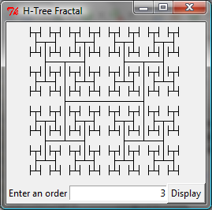

(a) (b) (c) (d)

The H-tree is used in VLSI design as a clock distribution network for routing timing signals to all parts of a chip with equal propagation delays. Write a JavaFX program that draws an H-tree, as shown in the figure.

Design:

Describe your recursive drawing method.

Paste your source code here:

Screen shot of two sample runs:

What to submit?

1. Paper copy of this document

2. Save/Compile and Submit (you must submit the program regardless whether it complete or incomplete, correct or incorrect)

3. Fill in self-evaluation:

1. Can your program display a single H shape? _______________
2. Can your program display H shapes recursively? _______________
3. Can your shape size change as you resize the window? _____________
4. Can your shape fill in the entire window when the window is maximized? _______________